1. **Define multimedia in education. Explain its role and significance in modern teaching and learning.**

* Multimedia in education refers to the integration of various digital elements such as text, graphics, audio, video, animations, and interactive content to enhance teaching and learning experiences. It leverages technology to present information in dynamic and engaging ways, catering to diverse learning styles.

**Role of Multimedia in Modern Teaching and Learning**

1. **Enhances Engagement**
   * Interactive videos, animations, and gamified content make learning more interesting and motivating for students.
   * Captures attention better than traditional text-based methods.
2. **Facilitates Better Understanding**
   * Complex concepts (e.g., scientific processes, historical events) can be simplified through visual and auditory aids.
   * Supports **dual-coding theory** (Paivio, 1986), where combining verbal and visual information improves retention.
3. **Supports Different Learning Styles**
   * Visual learners benefit from images and videos.
   * Auditory learners gain from podcasts and narrations.
   * Kinesthetic learners engage with interactive simulations.
4. **Encourages Active Learning**
   * Interactive quizzes, virtual labs, and simulations allow students to explore concepts hands-on.
   * Promotes problem-solving and critical thinking.
5. **Enables Distance & Flexible Learning**
   * E-learning platforms (e.g., Khan Academy, Coursera) use multimedia to deliver lessons remotely.
   * Supports **flipped classrooms**, where students learn via videos at home and engage in discussions in class.

**Significance in Modern Education**

* **Personalized Learning:** Adaptive multimedia tools cater to individual student needs.
* **Global Accessibility:** Breaks geographical barriers, providing quality education to remote learners.
* **Real-World Applications:** Prepares students for a tech-driven world by familiarizing them with digital tools.
* **Cost-Effective:** Reduces reliance on physical textbooks and allows scalable content distribution.

1. Describe the types of multimedia elements (text, graphics, audio, video, animation) and their applications in education.

* Multimedia in education combines different digital elements to create engaging and effective learning experiences. Each element **text, graphics, audio, video, and animation** play a unique role in enhancing teaching and learning.

1. **Text**  
   Text is the most basic yet essential multimedia element, consisting of written or printed words used to convey information.

**Applications in Education:**

* **E-books & Digital Notes:** Provides structured learning material in PDFs, Word documents, or e-readers.
* **Interactive Textbooks:** Includes hyperlinks, annotations, and embedded quizzes for active learning.
* **Online Articles & Blogs:** Supports research and self-paced learning.
* **Captions & Subtitles:** Enhances accessibility for hearing-impaired students and non-native speakers.
* **Discussion Forums & Chats:** Facilitates collaborative learning (e.g., Moodle, Google Classroom).

1. **Graphics (Images, Illustrations, Charts, Diagrams)**

Visual representations such as photos, infographics, icons, and mind maps that simplify complex information.

**Applications in Education:**

* **Infographics:**Summarize key concepts (e.g., timelines in history, scientific processes).
* **Diagrams & Flowcharts:**Explain processes (e.g., water cycle, programming algorithms).
* **Maps & Graphs:**Used in geography, economics, and statistics.
* **Interactive Whiteboards:**Teachers use digital drawings to explain lessons in real-time.
* **Flashcards:**Enhance memory retention (e.g., Anki, Quizlet).

1. **Audio (Sound, Music, Narration, Podcasts)**  
   Audio elements include spoken explanations, music, sound effects, and recorded lectures.

**Applications in Education:**

* **Podcasts & Audiobooks:** Useful for language learning, literature, and on-the-go education.
* **Lecture Recordings:** Allows students to revisit lessons (e.g., flipped classrooms).
* **Language Learning Apps:** Improves pronunciation and listening skills (e.g., Duolingo, Rosetta Stone).
* **Sound Effects in E-Learning:** Enhances engagement in simulations and games.
* **Text-to-Speech Tools:** Assists visually impaired students.

1. **Video (Recorded Lectures, Demonstrations, Simulations)**  
   Moving visuals combined with audio to demonstrate real-world scenarios or concepts.

**Applications in Education:**

* **Lecture Videos:** Used in MOOCs (e.g., Coursera, Khan Academy).
* **Science Experiments & Demos:** Shows dangerous or complex lab procedures safely.
* **Documentaries & Case Studies:** Enhances history, sociology, and medical education.
* **Virtual Field Trips:** Allows students to explore museums, space, or historical sites remotely.
* **Interactive Videos:** Includes quizzes and branching scenarios for active learning.

1. **Animation (2D/3D Motion Graphics, Simulations)**  
   Artificially created moving visuals that simplify abstract or complex topics.

**Applications in Education:**

* **Animated Explanations:** Breaks down difficult concepts (e.g., molecular biology, physics laws).
* **Interactive Simulations:** Allows virtual experiments (e.g., PhET for science and math).
* **Gamified Learning:** Uses animated characters and rewards to motivate students.
* **Medical Training:** Shows body functions, surgical procedures (e.g., 3D anatomy apps).

1. **Discuss the advantages and limitations of multimedia in classroom teaching.**

**Advantages of Multimedia in Classroom Teaching**

1. **Enhances Student Engagement & Motivation**

* **Interactive content** (videos, animations, quizzes) makes learning fun and reduces boredom.
* **Gamification** (e.g., Kahoot!, Duolingo) encourages participation through rewards.

1. **Improves Understanding & Retention**

* **Visual and auditory aids** help explain complex topics (e.g., 3D models in biology, animated math concepts).
* **Dual Coding Theory (Paivio, 1986)** suggests that combining text with visuals improves memory.

1. **Supports Different Learning Styles**

* **Visual learners** benefit from diagrams, videos, and infographics.
* **Auditory learners** gain from podcasts, narrations, and discussions.
* **Kinesthetic learners** engage with interactive simulations and virtual labs.

1. **Facilitates Active & Collaborative Learning**

* **Interactive whiteboards & digital tools** (e.g., Nearpod, Padlet) allow real-time collaboration.
* **Flipped classrooms** use multimedia (videos, e-books) for self-paced learning before discussions.

1. **Provides Access to Real-World Applications**

* **Virtual field trips** (Google Expeditions) take students beyond classroom walls.
* **Simulations** (e.g., flight simulators, chemistry labs) offer hands-on experience safely.

1. **Cost-Effective & Eco-Friendly**

* Reduces dependency on physical textbooks (saves costs and paper).
* Digital resources can be updated easily without reprinting.

**Limitations of Multimedia in Classroom Teaching**

1. **Technical Issues & Dependence on Technology**

* **Internet connectivity problems** disrupt online lessons.
* **Software/hardware malfunctions** (e.g., projector failure, app crashes) can delay teaching.

1. **High Initial Setup Costs**

* Schools need investment in **smartboards, tablets, VR headsets, and software licenses**.
* Requires **teacher training**, which adds to expenses.

1. **Distraction & Overstimulation**

* Too many animations/sounds can divert attention from core content.
* Students may focus more on **entertainment** than learning (e.g., gaming instead of studying).

1. **Passive Consumption of Content**

* Watching videos without interaction can lead to **superficial learning**.
* Lack of **critical thinking** if multimedia replaces discussions.

1. **Digital Divide & Accessibility Issues**

* Not all students have equal access to **devices or high-speed internet**.
* Students with **visual/hearing impairments** may struggle without proper adaptations (e.g., captions, screen readers).

1. **Explain multimedia instructional design with examples.**

* Multimedia instructional design is the process of **planning, developing, and delivering learning experiences** using a combination of different media forms such as **text, images, audio, video, animation, and interactive content** to improve teaching and learning effectiveness.

It is grounded in **learning theories** (like Cognitive Load Theory and Mayer’s Multimedia Learning Principles) that suggest learners learn better when words and visuals are combined meaningfully.

**Key Elements of Multimedia Instructional Design**

1. **Text** – Provides verbal information and explanations.  
   Example: Captions under a diagram in a biology lesson.
2. **Images/Graphics** – Illustrates concepts and aids memory.  
   Example: A labeled diagram of the human heart in a medical course.
3. **Audio** – Narration or sound effects that reinforce learning.  
   Example: A voice-over explaining the steps of solving a math problem.
4. **Video** – Demonstrates real-world applications.  
   Example: A video showing how a chemical reaction occurs in a laboratory.
5. **Animation** – Visualizes processes that are hard to capture in real life.  
   Example: An animation showing how planets revolve around the sun.
6. **Interactivity** – Engages learners actively through quizzes, simulations, or drag-and-drop exercises.  
   Example: An interactive module where learners match vocabulary words to their meanings.

**Examples of Multimedia Instructional Design**

1. **E-Learning Module (Science Class):**
   1. Animated video explaining photosynthesis.
   2. Narration + on-screen text with keywords highlighted.
   3. Interactive quiz at the end.
2. **Language Learning App (e.g., Duolingo):**
   1. Text for vocabulary.
   2. Audio clips for pronunciation.
   3. Pictures for word association.
   4. Gamified interactive exercises.
3. **Medical Training Simulation:**
   1. 3D models of human anatomy.
   2. Interactive case studies.
   3. Videos of surgical procedures.
4. **Corporate Training (Customer Service):**
   1. Scenario-based video role-plays.
   2. Text-based guidelines.
   3. Interactive branching choices to practice responses.

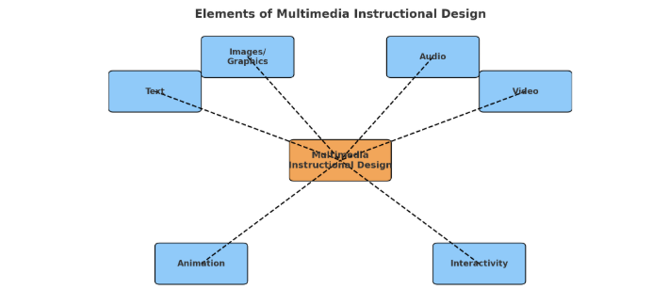

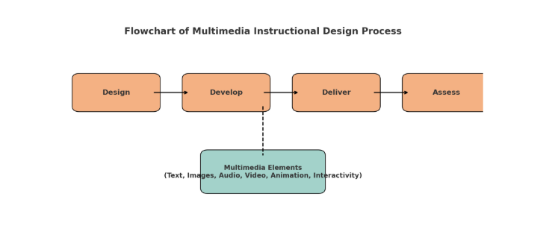Here’s a **diagram** showing how the different elements (text, images, audio, video, animation, interactivity) connect to form **Multimedia Instructional Design**.

Here’s a **flowchart** of the multimedia instructional design process:

* **Design → Develop → Deliver → Assess**
* The **Multimedia Elements** (text, images, audio, video, animation, interactivity) are integrated mainly during the **Develop** phase and support the overall process.

1. **Write short notes on:  
   a) Interactive multimedia  
   b) Hypermedia and its educational uses  
   c) Multimedia system components**
2. **Interactive Multimedia**

Interactive multimedia is a form of multimedia where users can actively engage and control the flow of information (rather than passively watching or reading).

**Features:**

* + Combines text, images, audio, video, animation, and interactivity.
  + Users make choices (e.g., click, drag, explore menus).

**Examples:**

* + Educational software (simulations, e-learning platforms).
  + Virtual labs where learners can perform experiments.
  + Video games with story branching.

**Educational Value:** Enhances learning by promoting active participation, problem-solving, and self-paced exploration.

1. **Hypermedia and its Educational Uses**

Hypermedia is an extension of hypertext that integrates text, images, audio, video, and links, allowing non-linear navigation.

**Characteristics:**

* + Provides linking and cross-referencing of multimedia elements.
  + Enables learners to explore content in their own sequence.

**Educational Uses:**

* **E-learning websites –** Students navigate through lessons with embedded links to videos, diagrams, and references.
* **Research tools –** Digital encyclopedias like Wikipedia.
* **Language learning apps –** Linking words with sounds, images, and examples.
* **Self-directed learning –** Learners can choose paths that fit their interests.

1. **Multimedia System Components**

A multimedia system consists of both **hardware** and **software** that work together to process and deliver multimedia content.

**Hardware Components:**

* **Input Devices:** Keyboard, mouse, microphone, scanner, camera.
* **Output Devices:** Monitor, speakers, projector, VR headset.
* **Storage Devices:** Hard disk, SSD, DVD, cloud storage.
* **Processor & Memory:** CPU, GPU, RAM to handle multimedia tasks.

**Software Components:**

* **Operating System:** Provides platform support for multimedia (Windows, macOS, Linux).
* **Authoring Tools:** Software for creating multimedia (Adobe Animate, Flash, Unity).
* **Playback Software:** Media players (VLC, Windows Media Player).
* **Communication Software:** Tools for online multimedia sharing (Zoom, Teams).